For immediate release: Contact:
Jamie Costanzo, Publicity Associate

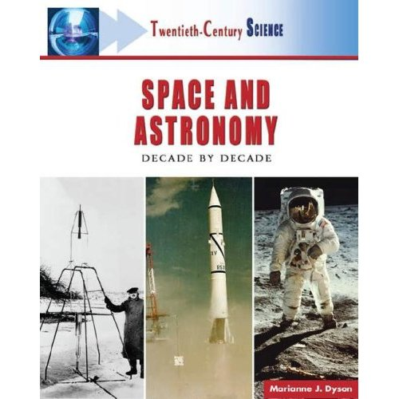
Phone: 212-896-4214
E-mail:jcostanzo@factsonfile.com

An Exciting New Look at

Space and Astronomy—Decade by Decade

Space and Astronomy is a captivating account of astronomers’ unraveling of the mysteries surrounding the impact and power of the Sun, how stars “collapse” into black holes, and the surprising scope of the universe. The 20th century was a period of remarkable discovery and exploration in space and astronomy, but the practical and spiritual connections of humankind with the stars has motivated and inspired improvements in observations and technology that has led to a deeper interest in exploring what lies beyond our galaxy.

Coverage includes:
- The development of a “new” astronomy  - Stars and relativity  - An expanding universe  - Modern rockets  - Wartime astronomy | - The dawn of space technology  - Space exploration  - Human achievements in space  - Laboratories in space  - Asteroids, comets, and extrasolar planets.

Each chapter in Space and Astronomy features milestones of significant events, sidebars that clarify scientific concepts, a “Scientist of the Decade” essay that focuses on a notable individual, and a list of print and Internet resources reflecting the time period. The book includes more than 80 photographs and line illustrations, an appendix of awards of merit in astronomy, a glossary, a list of general print and Internet resources, and an index.

—over, please—


About the Twentieth-Century Science set:
A History of Notable Research and Discovery
The 20th century witnessed an explosive growth in science and technology. New inventions—including spaceships, computer chips, lasers, and recombinant DNA—have opened pathways to new fields such as space science, biotechnology, and nanotechnology. Modern seismographs and submarines have given Earth and ocean scientists insight into the planet’s deepest and darkest secrets. Decades of weather science, aided by satellite observations and computer modeling, now produce long-term global forecasts with high probabilities of being correct.
Twentieth-Century Science, a new seven-volume set, provides students, teachers, and general readers with an accessible and highly readable source for understanding how science developed, decade by decade, during the last century—along with hints about where it is headed in the future. The history of science presented in this set teaches students about the benefits of making careful observations, of pursuing paths upon which others have not ventured to tread, and of always questioning the world around them.
Each volume features:

- One chapter for each decade, including its own introduction and conclusion
- A final conclusion that looks at likely trends in the 21st century
- Sidebars of famous scientists and notable events of the decade
- At least 50 line illustrations and 50 photographs
- Milestones of key events and discoveries, and more
- Glossary, index, and other back matter.
About the Author:

Marianne J. Dyson is a former NASA flight controller with a B.S. in physics from the University of North Carolina-Greensboro. She is a consultant for several science books, as well as a popular speaker on space topics. She won the Golden Kite Award for Space Station Science and the American Institute of Physics Science Writing Award for Home on the Moon.

SPECS:

Space and Astronomy: Decade by Decade
JUNE 2007

ISBN: 978-0-8160-5536-4. Hardcover. $49.50.
Black-and-white photographs and line illustrations. Index. Appendixes. Bibliography. Glossary. Cross-references. Further reading. Chronologies. Sidebars. Web sites.
Grades 6–12.
Facts On File, an imprint of Infobase Publishing

Tearsheets of any review or mention are greatly appreciated.
# # #

